~~rc-Lion and Grape Mirrors

1. Five Lion Dance

1.1. Introduction

1.1.1 Definition

1.1.2 Time Horizon

1.1.3 Geographical Extent

1.1.3.1 Western Regionss, Central Asia

The Five Lion Dance originated about 300 CE in Kucha, a multicultural Buddhist kingdom on the northern Silk Road route skirting the Taklamakan Desert in the Tarim Basin in the modern Aksu Prefecture of Xinjiang Uyghur Atononomous Province of the People's Republic of China. Its other names reflect its multi-cultural origins: [庫車](http://en.wiktionary.org/wiki/庫車) / Kuche; Uyghur كۇچار /Kuçar; Romanized, Qiuzi, Qiuci, Chiu-tzu, Kiu-che, Kuei-tzu; Sanskrit, Kucina; Tibetan, Kutsahiyui.

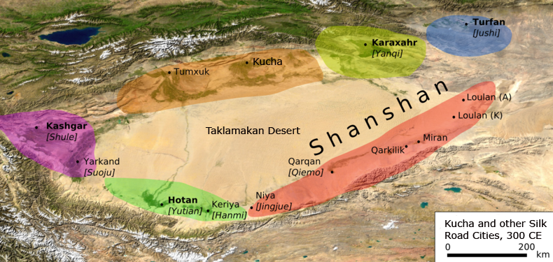

The five Western Regions kingdoms (Hotan, Kashgar, Kucha, Karaxahr and Turfan) that were to become emblems of China's hegemony in the Five Lion Dance. Map with modifications after http://upload.wikimedia.org/wikipedia/commons/thumb/d/d0/Tarimbecken\_3.\_Jahrhundert.png/800px-Tarimbecken\_3.\_Jahrhundert.png.

Kucha is renowned for its expert dancers who perform regularly at communal ceremonies, a tradition that goes back some 2500 years at least.

The *Tang-ch 'i* chronicle describes a musical dance scene originat­ing from Kucha:

"a zither, a harp, a lute, a flute, a mouth organ, several drums and four dancers par­ticipate. This is called the dance of the five lions. The lions appear in five differ­ent colours and they are taller than one *jo* [approximately three metres]. Twelve men lead one lion... " (Harich-Schneider 1973: 166).

This description is at variance with the *Yueh-fu tsa-lu* of An-ch'ieh Tuan, fl. 880 CE (Tuan 1985; Gimm 1966). Our line-by-line translation of the description of the dance by An-ch'ieh Tuan follows (Chinese text from *Yuefu Miscellany*, http://www.tianyabook.com/gudian/yuefuzalu/index.html):

#### "Order of the Qiuci [Kucha] Ceremony"序龟兹部》

#### 1) The music is arranged with a bamboo horn, a flute, and a four-pitch Jie drum (羯 鼓).

#### 乐有觱篥、笛、伯板、四色鼓、揩羯鼓、鸡楼鼓

#### 2) Five lions play with feet exposed and with colored clothing. 戏有五方狮子，高丈馀， 各衣五色。

#### 3) Each lion has red whiskers and is comprised of 12 people who wear red-colored garments and performs in what is called the "Lion Cub" dance accompanied by the "Peace Music" song. 每一狮子有十二人，戴红抹额，衣画衣，执红拂子，谓之“狮子郎”， 舞《太平乐》曲。

#### 4) "Prelude of Dissonant Music." This melody is in the Qin system in which everyone dances in a colored garment. They carry flag pennants; in spring and winter the foreign rival principalities give tribute to the military in dancing this song. Concurrently, the cavalry enters the field, which is particularly spectacular. [This scene shows how the entering Chinese cavalry subdues the dissonant foreign rival principalities. In earlier versions of the dance the five rival principalities were probably portrayed as being in harmony among themselves without an intruding Chinese cavalry contingent.]

#### 《破阵乐》曲亦属此部，秦王所制，舞人皆衣画甲，执旗旆；外藩镇春冬犒军亦舞此曲，兼马军引入场，尤甚壮观也。

#### 5) Then the "Ten Thousand Years Song," which is also known as the Wei song, is also called "Heaven's Immortal Child."《万斯年曲》，是朱崖李太尉进此曲名，即《天仙子》是也。[Celebrating the fact that harmony will last ten thousand years and the Shang-ti is blessing the event as his "child" or progeny.]

ICONOGRAPHY OF THE FIVE LION DANCE

From what we can see from this account, the Kucha Five Lion Dance is a product of several cultural traditions.

Iconography of the Tree of Life and the Tree of Death.

Mandaean iconography extolls Trees of Life as paradisical trees in at least sixty texts, but these trees are primeval and not yet the vine proper. In Mandaeaism it is the male date palm (Mandaean *sindirka*) that is the Tree of Life and which depends on the waters of the well (Mandaean *'aina*) as the female principle to complete the "sacred marriage." Out of this union of the tree and water, of the Tree of Life, Mandaean vine iconography is born, for the vines grow in the trees, as the faithful are supported by the Tree of Life, so that there is a continuum from tree to vine as the sources of Life in the Lightworld for the faithful (Ryen 2006:203). Note that in the depiction of the Tree of Life in the Sangim grotto the leaves of the tree are not green but white, reflecting the idea that they are the source of Life in the Lightworld. Furthermore, the grape clusters are thoroughly integrated with the tree so that they appear to be its fruit. Above the tree is the Buddhist addition of of lotus blossoms as symbols of Buddhist enlightenment.

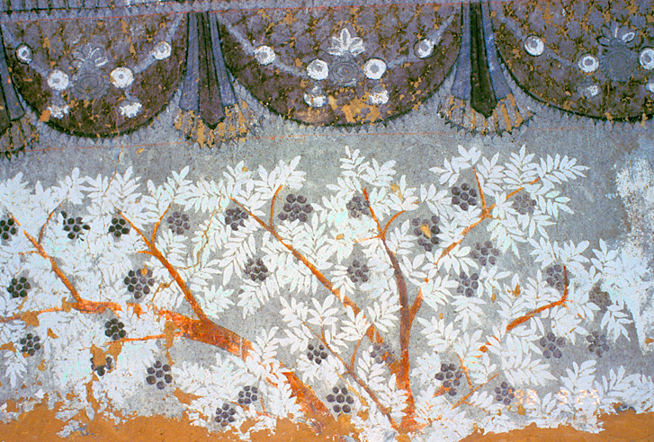

The Tree of Life inside the Manichaean Temple Grottoes of Sangim (Shengjinkou), Turfan showing the Mandaean/Manichaean Tree of Life, the entwining vines and the Buddhist lotus blossoms above. Photographed by Noboru Ogata (1998). http://www.hgeo.h.kyoto-u.ac.jp/ogata/turpan1998/shengjinkou-cave\_01\_e.html

However, in Manichaean dualism, there is also a corresponding Tree of Death that symbolizes evil and destructive forces, and this dualism portrayed in the Sangim grottoes clearly indicates the presence of Manichaean iconography in addition to the Mandaean and Buddhist symbolism that is present as well.

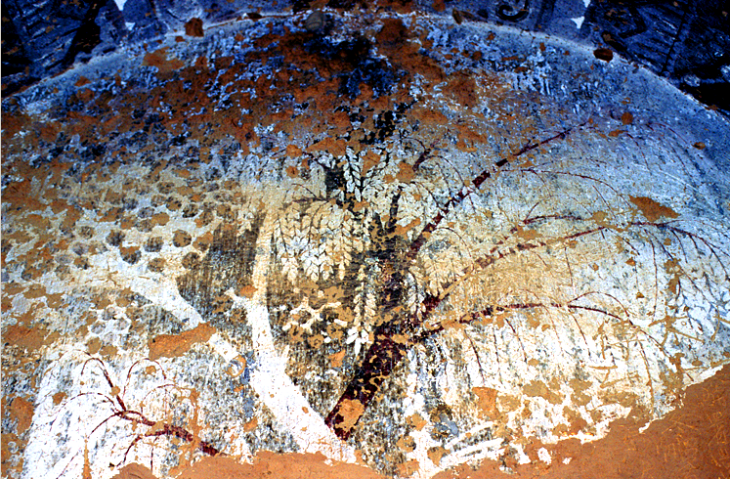

The Tree of Life and the Tree of Death inside the Manichaean Temple Grottoes of Sangim (Shengjinkou), Turfan. The white tree (Tree of Life) and the black tree (Tree of Death) symbolize the Gnostic dualism of good and evil at the heart of Mani's doctrine. Photographed by Noboru Ogata (1998). http://www.hgeo.h.kyoto-u.ac.jp/ogata/turpan1998/shengjinkou-cave\_02\_e.html

Iconography of the Vine

Among these traditions are Christianity and Mandaeism that had a highly developed iconography of the vine in which Jesus (John 15) and Miriai (JB 129,19) are personified as vines and who are simultaneously representative of all believers as well (Ryen 2006: 304-305). However, as we can see in the frescoes in the grottoes of Kucha and Turfan (Bezeklik) there are depictions of vines that are adorned with precious stones, pearls and birds. This iconography appears to be distinctly a Mandaean derived symbolism and is distinguished by its exuberance from the austerity of the Johannine imagery (Percy 1939:234). It appears, then, that this imagery was taken up by Manichaeanism and added to its religious iconographic repertoire in these grottoes. Furthermore, this lush, vine imagery appears to be incorporated into the Five Lion and Grape mirror iconography as it was expressed in the later Sui and Tang dynasties.

Anyone who has stood under the grapevine arbors in Kucha and Turfan cannot help but appreciate this imagery as the sunlight sparkles through the maze of clusters of yellow grapes with their green leafy foliage, growing from the water as it is channeled through the town from the underground *karez* that bring the waters of the mountains to the people. It is this imagery, we believe, that is incorporated into the iconography of the tree and the vine in the Five Lion and Grape mirrors.

Iconography of the Lion

Since the lion never was in the Western Regions, its origins lie to the west, in the zone of Mesopotamia and Persia and to the south, Tibet and India. The Persian Sogdian depiction of the lion hunt in the early Islamic period (7th century CE) proves lions were in Persia at this time, although its iconography is entirely different from than that which is displayed on the Five Lion Dance mirrors (Azarpay 1981:172). In fact, the Chinese word for "lion" is 獅子 (Shīzi) and is transliterated from the Persian Shir (شیر). The lion was first sent from the western lands as tribute to China from the area of present-day Afghanistan, then known as Wuyi shanli 烏戈山離 or Paite 排特. Wuyi shanli, the terminus of the southern branch of the Silk Road that led from the Western Regions (modern Xinjiang) to Central Asia (Ban 1938). The lion’s ferocity earned it such Chinese names as “Heaven’s Blessing” (tianlu 天祿) and “Exorcist of Evil” (bixue 辟邪). In the *Biography of King Mu* 穆天子傳 the lion of the Western Regions is described as at resembling the tiger but more ferocious and claimed tigers and panthers as its prey (Shanxiang 1999). The lion was called Suān ní 狻猊, a transliterated word from a dialect in the Western Regions described in the tenth century CE dictionary *Er ya* /爾雅 of Bing Xing (1965) as "a short-haired tiger".

The protective power rather than its ferocity is what is incorporated into the Dance of the Five Lions mirrors. This aspect of Chinese lion iconography is reflected in stone carvings placed in front of tombs and palace gates or shrine doors, where lions function like guardians, and, like griffins in Western culture, they are often winged.

About the second century CE Buddhism made its way into China from Tibet and India, where an iconography had developed with the lion as a symbol of the Buddha, who was called Shakyasimha, 'the lion among the Shakyas", the clan to which he belonged. As early as 208 BCE lions were incorporated in Buddhist monumental art.

This iconography was brought into China by Buddhist pilgrims who traveled the Silk Road from India through Kashgar, east to Kucha, Karaxahr, Turfan, Dunhuang, Xian and Ningbo. From Xian the iconography of the Buddhistic lion spread northeast to Korea and Japan and southeast to Ningbo and Guangdong. In these locales there developed a desire to encapsulate the protective nature of the lion, and this became fused with the sense of the five Kingdoms of the Western Regions as preotecting China from hostile forces to the west.

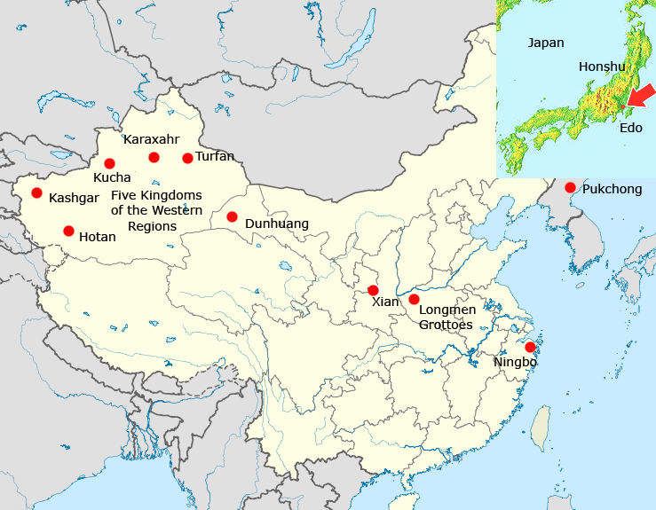

Map of the distribution of the Five Lion Dance

1.1.3.2 China

How the Five Lion Dance originated is open to speculation. There is a quaint folktale that combines the protective role of the lion and the origin of the lion dance in a picturesque account (Goswamy 2002):

A long time ago, it is said, a people-eating monster, the nien, attacked the villages of China. The people turned to the lion for help, and he immediately attacked the nien, driving him away. Unfortunately, the monster returned the following year, too, but this time the lion was too busy guarding the imperial palace to come and help. The villagers, therefore, constructed a fake lion of cloth and bamboo, and two of them hid inside, prancing and roaring like a lion, and successfully scared the nien away. Ever since then, it is said, the Lion Dance has been a feature of the New Year celebrations, chasing away evil, and bringing good fortune to all.

We do know for certain that the Five Lion Dance in China was known in the Sui Dynasty (581-618 CE) which was accompanied by the Tàipíng lè or "Peace Music" (太平乐), signaling that the Five Kingdoms of the Western Regions were in harmony with (and in tribute to) the Chinese court. Following the demise of the Sui dynasty and the Li (李) family's seizure of power on June 18, 618 CE, the Five Lion Dance was listed as the sixth of "the Nine Classes" of "Banquet Music." When Gaochang was incorporated into the Chinese realm in 642 CE the number of dances was increased to ten. When the classes of music were divided into "Standing" and "Sitting" subsequently, Kucha's "Lion Dance of the Five Regions" (also known as the "Great Peace Music" for the Dance" (Picken 1988, 4:32). The "Lion Dance of the Five Regions" was a celebratory ceremonial for continuing peace in the Western Regions. Its popularity was ensured, since the Chinese court was ensconced at its capital in Xian (modern Chang-an). Xian at this time was the most important cultural center in China being the eastern terminus of the Silk Road, and it was also the most populous city in the world.

Po Chü-i (Bo Juyi) /白居易 (772–846), a revered poet and responsible Tang dynasty civil servant, reflected on the distant origins of the Five Lion Dance as he had seen it performed at Loyang near the Longmen grottoes where he spent his last days compiling his collected works (Waley 1941, 1949):

*Skilled dancers from Xinjiang,*

*Persian masks and lion masks.*

*The heads are carved of wood,*

*The tails are woven with thread.*

*Pupils are flecked with gold*

*And teeth capped with silver.*

*They wave fur costumes*

*And flap their ears*

*As if from across the drifting sands*

*Ten thousand miles away…*

1.1.3.3 Korea

The Pukchong (Bukcheong) Saja-nori lion dance tradition has its roots in Korean shamanism. Although there are several other lion dances as part of Korean mask plays, Pukchong Saja-nori is peculiar in that it is exclusively composed of lion dance, unlike other mask play traditions. Pukchong is a county in eastern South Hamgyong province, North Korea. The tradition had been kept up in the county of Bukcheong -gun, Hamgyungnam-do, in North Korea until the 1930s. At the time of the Korean War in 1950, North Korean performers fled to South Korea in an attempt to preserve the dance, since it was outlawed in the north because shamanism was considered a threat to Communism. It is currently assigned as South Korea's Important Intangible Cultural Property No. 15.

The Korean lion, or "saja," is a costume manipulated by two or three performers. The head of the lion consists of a flat, round, grotesque-looking mask with bells hanging from it. Like its Chinese and Japanese counterparts, it is performed during the lunar new year celebration to fend away evil spirits and beckon good luck.

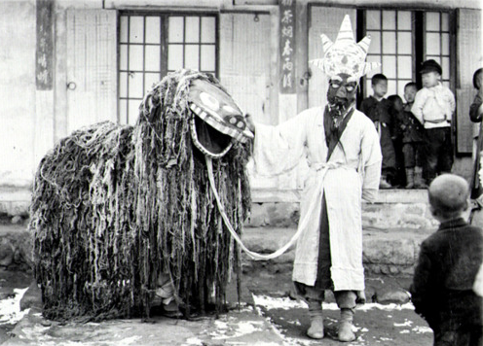

A Pukchong Korean lion dancer and his accompanist.. From http://25.media.tumblr.com/tumblr\_m0o7vqAr041qb2ab9o1\_500.jpg

1.1.3.4 Japan

The lion dance is one of the most popular of *kagura* ceremonies and folk feasts, the *matsuris,* which are performed inside the shrines as well as on stages in the area in front of shrines. The word *shishi* itself means "lion", people do not recall the real animal, but rather the image of the mythical creature. Lions have never lived in Japan, and the cult of the lion, having originated in the Western Regions of what is now Xinjiang Province diffused with Buddhism and reached Japan along the Silk Road along with Buddhist mythology and Chinese Tang court music and dance, which the Japanese imperial court adopted and adapted.

The Lion dance became part of popular culture and continued into the Edo period. A description of the Lion dance as it was received from Korea was recorded by Aimé Humbert (1874: 300-302) in the early 1870's:

"Perhaps nothing more serious is going on than the dance of the Lion of Corea. How (often everyone [in Edo, central Honshu] has seen it! And nevertheless the discordant appeal of the fife and the tambourine which announce its approach is never resisted. Four actors come out of a neighbouring street; three form the orchestra, and the fourth gives the representation. He is wrapped in a very large striped cloak surmounted by an enormous lion's head. The monster can make himself longer or shorter at will, and suddenly raise himself up two yards above the people who are with him. The children utter cries of mingled admiration and fear. Some, bolder than the rest, venture to lift up the skirts of his cloak, and even to pinch the legs of the mysterious tumbler."

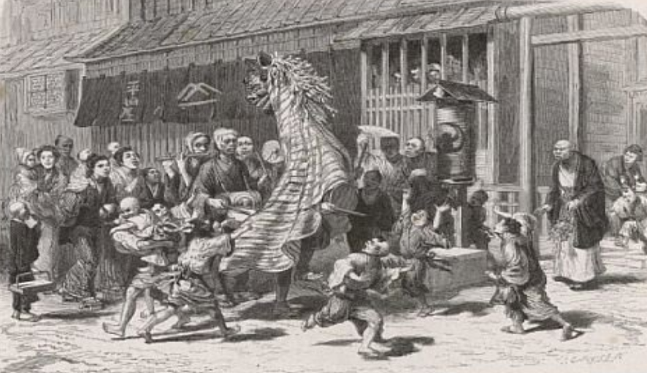

Japanese children when a street dancer enacts the role of a Korean Lion. Nineteenth century engraving. After http://www.yushodo.co.jp/pinus/59/library%27santiq/pic\_m4.html.

"He sometimes frightens them, by turning his head towards them, opening his mouth, and shaking the thick mane of scraps of white paper which surrounds his scarlet face; then he will begin to dance to the sound of the instruments of his companions. He carries his tambourine himself, but as soon as he leaves off dancing he sets it down, and, suddenly stooping, transforms himself into a quadruped, executes some grotesque gambols, and finishes by stripping off his accoutrements. Then the monster vanishes, but the juggler remains. He seizes a drumstick and balances it on the thumb of the left hand; he puts a second stick on the end of the first, and a third crosswise above the other two; finally, he throws them into the air, catches them with his hands, and spins them about more and more rapidly and uninterruptedly, adding one, two, or three balls, which come from no one knows where. The admiration of the spectators is at its height. One of the musicians passes round a plate—that is to say, a fan. The representation is finished, and the juggler lights his pipe from that of some benevolent neighbour. It is not uncommon to see him negligently putting on his costume again, and sitting calmly smoking, with his head covered down to his nose with the enormous and grotesque mask of the monster. The latter is the most picturesque part of the spectacle."

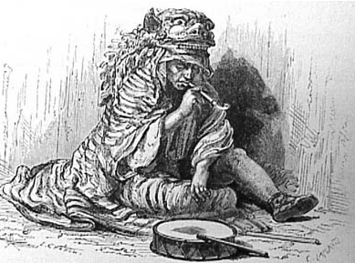

Japanese Lion dancer after the performance. Nineteenth century engraving. After http://www.yushodo.co.jp/pinus/59/library%27santiq/pic\_m4.html

The lion dance has been completely absorbed into Japanese tradition and is used even in religious Shinto festivals aside from new year celebrations. The Japanese lion consists of a wooden, lacquered head called a "shishi-gashira" (lit. Lion Head), and a characteristic body of green dyed cloth with white designs. It can be manipulated by a single person, or two people, one who manipulates the head. As with Chinese lions, the head and designs on the body differ from region to region, and even from school to school.

In Okinawa, a similar dance exists, though the lion there is considered to be a legendary [shisa](http://en.wikipedia.org/wiki/Shisa). Shisa (シーサー) ([Okinawan](http://en.wikipedia.org/wiki/Okinawan_language): *siisaa*) ([shishi](http://en.wikipedia.org/wiki/Shishi_(stone_lion)) or shisaa) is a traditional [Ryukyuan](http://en.wikipedia.org/wiki/Ryukyuans) decoration, often in pairs, resembling a cross between a lion and a dog, from [Okinawan](http://en.wikipedia.org/wiki/Okinawa) [mythology](http://en.wikipedia.org/wiki/Mythology). People place pairs of shisa on their rooftops or flanking the gates to their houses. Shisa are wards, believed to protect from some evils. When in pairs, the left shisa traditionally has a closed mouth, the right one an open mouth.[[1]](http://en.wikipedia.org/wiki/Shisa" \l "cite_note-0) The open mouth wards off evil spirits, and the closed mouth keeps good spirits in.

Its close resemblance in both appearance and name to the Chinese [sanxian](http://en.wikipedia.org/wiki/Sanxian) suggests its Chinese origins, the old [Ryūkyū Kingdom](http://en.wikipedia.org/wiki/Ryūkyū_Kingdom) (pre-Japanese Okinawa) having very close ties with China. In the 16th century, the sanshin reached the Japanese trading port at [Sakai](http://en.wikipedia.org/wiki/Sakai,_Osaka) in [Osaka](http://en.wikipedia.org/wiki/Osaka_prefecture), [Japan](http://en.wikipedia.org/wiki/Japan). In mainland Japan, it evolved into the larger [shamisen](http://en.wikipedia.org/wiki/Shamisen).

The heads, bodies and behavior of the shisa in the dance are quite different than the [shishi](http://en.wikipedia.org/wiki/Shishi) on mainland Japan. Instead of dancing to the sounds of flutes and drums, the Okinawan shisa dance is often performed to folk songs played with the [sanshin](http://en.wikipedia.org/wiki/Sanshin). The sanshin ([三線](http://ja.wikipedia.org/wiki/三線), literally "three strings") is an [Okinawan](http://en.wikipedia.org/wiki/Okinawa) musical instrument and precursor of the Japanese [shamisen](http://en.wikipedia.org/wiki/Shamisen). Often likened to a [banjo](http://en.wikipedia.org/wiki/Banjo), it consists of a neck and three strings with a snakeskin-covered body, which is symbolical,ly important since the shisa is often portrayed as eating a snake.

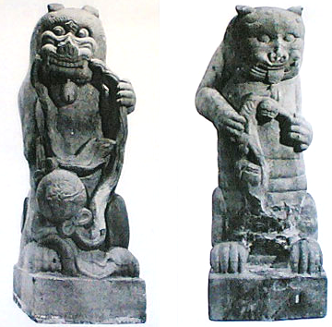

Possible Edo period Shisa /シーサー, from Okinawa, after http://okiken.com/uploads/thumbs/4.jpg

When a Chinese emissary returned from a voyage to the court at Shuri Castle, he brought a gift for the king, a necklace decorated with a figurine of a *shisa*-dog. The king found it charming and wore it underneath his clothes. At the Naha Port bay, the village of Madanbashi was often terrorized by a sea dragon who ate the villagers and destroyed their property.

One day, the king was visiting the village, and one of these attacks happened; all the people ran and hid. The local noro (priestess of the Ryukyuan religion) had been told in a dream to instruct the king when he visited to stand on the beach and lift up his figurine towards the dragon; she sent the boy, Chiga, to tell him the message.

He faced the monster with the figurine held high, and immediately a giant roar sounded all through the village, a roar so deep and powerful that it even shook the dragon. A massive boulder then fell from heaven and crushed the dragon's tail. He couldn't move, and eventually died.

This boulder and the dragon's body became covered with plants and surrounded by trees, and can still be seen today. It is the "Gana-mui Woods" near Naha Ohashi bridge. The townspeople built a large stone *shisa* to protect it from the dragon's spirit and other threats (Sesoko 1973).

2. Lion and Grape Mirrors

2.1. Introduction

2.1.1 Definition

2.1.2 Time Horizon

2.1.3 Geographical Extent

2.1.3.1 Western Regionss, Central Asia

2.1.3.2 China

2.1.3.3 Korea

2.1.3.4 Japan

Bronze mirrors were introduced into Japan from China and Korea during the Yayoi period (about 300 BC - AD 300). At first Japanese mirrors had a religious function and were based on the Han designs regarded as symbols of authority. However, the Japanese soon learned to make their own mirrors using the lost-wax technique, decorating them initially with Chinese and then native Japanese designs.

The adaptation of the Chinese Lion Dance to designs on mirrors during the later Sui and Tang dynasties was known from its popularity at Xian. During the Nara period (710-794 CE) reports and examples of mirrors brought back to Japan from China via Korea created an awareness of this particular dance and art form. These Five Lion Dance mirrors were generally small (up to three inches in diameter) and produced by the loss wax process. Later, in addition to Chinese designs on mirrors there was a growing use of Japanese designs, such as native plants and animals symbolizing good fortune. From the Kamakura period (1185-1333) a design showing Hôraizan (the Chinese 'Island of Immortality') became popular. Mirrors gradually became more robust with a central boss, often in the shape of a tortoise, which was pierced and a cord.

More new designs and the first handled mirrors appeared in the Muromachi period (1333-1568). During the Edo period (1600-1868), mirrors decorated with lucky symbols or Chinese characters were given at weddings. Mirrors became larger as hairstyles became more ornate; some mirrors in Kabuki theatre dressing-rooms were up to fifty centimetres across and were placed on stands. The faces of mirrors were highly polished or burnished, with itinerant tinners and polishers specializing in this work. Since the mirror, together with the sword and the jewel, were symbols of Imperial power, mirror-makers were deeply revered and often given honorary titles such as Tenka-Ichi ('First under Heaven'). However, this title was often misused and was officially prohibited in 1682.

2.2. Cultural Backgrounds

2.2.1. The Mandaean Background

2.2.2. The Manichaean Background

2.2.3. The Taoist Background

2.2.4. The Buddhist Background

REFERENCES

Azarpay, Guitty. 1981*. Sogdian painting: the pictorial epic in Oriental art. Berkeley*: University of California Press.

Ban, Gu (32-92 CE). 1938. *The history of the former Han dynasty* New York: Waverly. 3v.

Humbert, Aimée. 1874. *Japan and the Japanese*. London: Richard Bentley, 1874.

Gimm, Martin. 1966. *Das Yueh-fu tsa-lu des Tuan An Chieh. Studien zur Geschichte von Musik, Schauspiel and Tanz in der T'ang-Dynastie*. Wiesbaden: Harrassowitz

Goswamy, B. N. 2002. Celebrating with the Lion Dance. *The Tribune, Spectrum,* Oct. 6. http://www.tribuneindia.com/2002/20021006/spectrum/art.htm

Harich-Schneider, Eta . 1973. *A History of Japanese Music,* London: Oxford University Press.

Percy, E. 1939. *Untersuchungen ueber den Ursprung der johanneischen Theologie. Zugleich ein Beitrage zur Frage nach der Entstehung der Gnostizismus*. Lund: Gleerup.

Picken, Laurence. 1988. *Music from the Tang Court*. Cambridge: Cambridge University Press. v. 4.

Ryen, John Olav. 2006. *The tree in the lightworld: a study in the Mandaean vine motif*. Oslo: University of Oslo.

Sesoko, Chizue. 1973. *Legends of Okinawa* [Urasoe, Japan]

Shanxiang, Wu. 1999. *Biography of King Mu - A Legendary Book from Ancient China*. Chinese literature. no. 3, (1999): 143. [Peking, Foreign Languages Press].

Tuan, An-chieh / 段安節 [Duan, Anjie]. 1977. Yueh-fu tsa lu / 樂府雜錄 . Taipei : Tai lian guo feng chu ban she, Minguo 66.

Waley, Arthur. 1941. *Translations from the Chinese.* New York : A.A. Knopf.

Waley, Arthur. 1949. *The life and times of Po Chu-i*, *772-846 A.D.* London, G. Allen & Unwin.

Xing, Bing (932-1010 CE). [1965]. *Er ya zhu shu* /爾雅注疏 . Taipei Shi : Taiwan Zhonghua shu ju, Minguo 54 .

*Yuefu Miscellany*, http://www.tianyabook.com/gudian/yuefuzalu/index.html), accessed May 17 2012.